***A Mini Project Report on***

**Orphanage Donation**

**TE I.T.**

**Engineering** **Submitted By**

**Ritvik Shetty 20104067**

**Srusti Patil 20104066**

**Riya Sawant 20104078**

**Under The Guidance Of**

# Prof. Apeksha Mohite



# DEPARTMENT OF INFORMATION TECHNOLOGY

**A.P.SHAH INSTITUTE OF TECHNOLOGY**

**G.B. Road, Kasarvadavali, Thane (W), Mumbai-400615 UNIVERSITY OF MUMBAI**

**Academic year : 2022-23**

# CERTIFICATE

This to certify that the Mini Project report on **Orphanage Donation** has been submitted by 20104067, 20104066 and 20104078 who are a Bonafede students of **A. P. Shah Institute of Technology, Thane,** as a partial fulfilment of the requirement for the degree in **Information Technology**, during the academic year **2022-23** in the satisfactory manner as per the curriculum laid down by **University of Mumbai**.

Apeksha Mohite

**Guide**

Dr. Kiran Deshpande Dr. Uttam D.Kolekar

**Head Department of Information Technology** **Principal**

**External Examiner(s)**

1.

2.

**Place**: A.P.Shah Institute of Technology, Thane **Date:**

**ACKNOWLEDGEMENT**

This project would not have come to fruition without the invaluable help of our guide

**Orphanage Donation**. Expressing gratitude towards our HoD, **Prof. Kiran Deshpande**, and the Department of Information Technology for providing us with the opportunity as well as the support required to pursue this project. We would also like to thank our teacher Ms. **Yaminee Patil** who gave us her valuable suggestions and ideas when we were in need of them. We would also like to thank our peers for their helpful suggestions.

**ABSTRACT**

Almost, here are more than 100 million orphans worldwide. They are hungry, afraid, and lonely. Their main issues are lack of food and clothes for their daily usage and lack of education and money. Here, we introduce a web application that will easily defeat these issues as well as quickly without spending more time. The objective of this paper is to support the orphans of different orphanages by the people who wish to contribute to the children and adopt children online by using our web-application. They can help orphans in the orphanages by contributing foods and clothes to the orphanage they wish, through online. The people who wish to adopt children can use this application to see the children's details with their photos in different orphanages and they can choose the child they like and other formalities are done by visiting that orphanage where the chosen orphan is. Fund transactions are also made by our application. This paper will be beneficial for the orphans. The weary persons can make use of this application for contributing orphans and adopting children. This web application not only indulges in the process of adopting the orphans and providing shelter but also impulses their life by donating food, clothes, and money.

## TABLE OF CONTENTS

1. Introduction…………………………………………………………………...1

1.1.Purpose..................................................................................................... 1

1.2.Problem Statement………………………………………………………1

1.3.Objectives................................................................................................. 2

1.4.Scope........................................................................................................ 2

1. Literature Review…………………………………………………………......3
2. Proposed System………....................................................................................4

3.1. Features and Functionality………………………………………………4

1. Requirements Analysis...................................................................................... 5
2. Project Design...................................................................................................6

5.1.Use Case diagram………………………………………………….…… 6

5.2.DFD (Data Flow Diagram) ……………………………………………...7

5.3.System Architecture……………………………………………………...7

1. Technical specification……………...……………………………………..…..8
2. Project Scheduling..............................................................................................9
3. Implementation…………………………………………………………….. ...10

9. Result and Discussion……………………………………………………..… 13

10. Conclusion and Future Scope............................................................................14

11. References …………………………………………………………………....15

**Chapter 1**

**Introduction**

An orphanage is a residential institution devoted to the care of orphan-children whose parents are unwilling or unable to take care of them. The problem of orphan is acute due to urbanization and industrialization. Need for each of the orphanages varies in different categories such as food, money, clothes, medicine. Most of the people would like to help the orphanages but the major problem is that they have no idea on how to approach these orphanages. The main objective of this application is to develop a centralized site for orphanages. In our proposed system we try to create an interface between Orphanages which need charity and people/Volunteers who are willing to help these people. People can donate through Internet Banking or Online Money Payment applications. Most of the children in orphanages suffer from malnutrition because they are fed with less amount or unhealthy food. Due to low caring and unwilling to take care of children by their parents the count of children in orphanages had increased linearly. Although the count of children is increasing, the charity provided for the orphanages is lesser in ratio. With the help of our website this problem can be easily resolved or reduced. This website is developed to increase or ease the charity provided for the orphanages. Site Builder software can be used to develop the site with ease.

* **Problem Identified:**

The practical difficulty is finding out the real orphans and the less knowledge about the donation details. The majority of NGO's has experienced difficulties on getting funds or other things. Getting donor is a hard task, and sometimes dealing with some donor’s condition can be a big challenge

* **Solution Proposed:**

Our application allows the users to search and find the orphanages or children in need of money on internet and then they can donate with the orphanages whichever they want

**1.1Purpose**

The purpose of orphanage donation website is to create an interface between Orphanages which are in need of charity and people/Volunteers who are willing to help these people. A donation page is a web page located on a non-profit’s website where supporters have the opportunity to contribute funds to the organization’s mission online rather than by mail or in person. Donation website provide a convenient way to contribute, not requiring travel, envelopes, or stamps for supporters to give. This low barrier to entry means that any supporter with a computer, smartphone, or access to the internet can give from the comfort of their home.

**1.2 Problem Statement**

Nowadays user don’t have a proper application for raising funds or donation and make it available to the needful people. So using this application users can donate as much amount as they want to help the needy ones at orphanages so that even they can live a better life.

**1.3 Objective**

* To help needy to get great support and affection from the people around them.
* To maintain social, ethical and organizational norms.
* To reduce lack of awareness.
* To increase the reach of donors who are willing to donate.
* To reduce paper work and time.
* To build awareness about the needy people around the world.
* To donate different things like money or food or anything that will help needy ones
* To develop a user-friendly portal that can be accessible anytime and anywhere.

**1.4 Scope**

* Can be used to reduce paperwork.
* Can be used to make donation work easy through online mode.
* Can be useful for raising funds
* Can try to contribute our best by connecting the people in need with the providers and donors.
* Can see the details of the people who are seeking for help and if they wish to help, they have to register themselves.

# Chapter 2

**Literature Review**

Case Paper 1 :

This paper extends previous literature reviews focusing on fundraising and the mechanisms motivating charitable giving. We analyse 187 experimental research articles focusing on fundraising, published in journals across diverse disciplines between 2007-2019. Interest in studying fundraising spans many disciplines, each of which tends to focus on different aspects, supporting earlier claims that fundraising has no single academic “home.” Most of the literature focuses on two key areas: the philanthropic environment in which fundraising occurs, largely focused on potential donors’ experiences, preferences, and motivations; and testing fundraising tactics and techniques that result in different behaviour by potential donors. More than 40% of the experiments were published in Economics journals. Correspondingly, topics such as warm glow and mechanisms such as lotteries, raffles, and auctions are well represented. Experimental studies largely omit the practical and the ethical considerations of fundraisers and of beneficiaries. For instance, studies focusing on the identified victim phenomenon often stereotype beneficiaries in order to foster guilt among donors and thereby increase giving. We identify several opportunities for research to examine new questions to support ethical and effective fundraising practice and non-profit administration.

Case Paper 2:

Americans only give about 2% of their income to charity, and most of that money goes to charities that don’t do an especially good job of helping people. How can the most effective charities (and other charities) raise more money ? There are many different techniques that have been shown to work well in multiple studies, but evidence on most techniques is still very mixed, and some popular techniques in the real world have no experimental evidence behind them. Charities really ought to run more experiments to figure out which techniques will work for them.

Case Paper 3:

[The FOOD Pantry Serving Waukesha County](https://www.waukeshafoodpantry.org/) is a non-profit community organization in Wisconsin, dedicated to providing food, hope, and dignity to the many Waukesha County residents in need of assistance. The FOOD Pantry strives to contribute towards a thriving and healthy community free from hunger. As a part of their fundraising outreach, The FOOD Pantry staff set a goal to [engage their board](https://www.networkforgood.com/resource/how-to-motivate-and-involve-your-board-members/) in fundraising to help amplify their message through peer-driven campaigns. To accomplish this, they decided to create a peer-to-peer campaign using Network for Good’s fundraising software.

**Proposed System**

In the existing system everything is done manually on papers. This reduces the efficiency as well as the possibility of mistakes is very high, so for copying up the current environment the need arises for a “computerized system” which will increase the efficiency and reduce errors to its minimum and should be cost effective. Computerization brings along with itself a much higher degree of efficiency and sheet up the data processing. Very low degree of probability of computational errors which also generally occurs due to faulty inputs. Few skilled Student can undertake the job with ease, thus cutting down the man power can possible. Retrieval of data as backing is available. Updating of records become simple and fast.

**3.1 Features and Functionality**

* **Safe and Secure**: User will receive a receipt after successfully donating to the organisation . There is no risk of data miss-management at any level while the project development is under process.
* **Cause:** User can donate to a cause according to his will such as medical purpose , educational purpose or other things .
* **Detailed Information**: User can get detailed information about the NGO or the purpose in which he or she wants to donate. With proper steps given for user convenience

## Requirement Analysis

**Functional requirements**

* System must be able to verify and validate information.
* The system must encrypt the password of the user to provide security.
* Username and password will be used for login after user registration is confirmed.

**Hardware requirements**

* **RAM**

The application requires a device with a minimum of 512MB RAM while running.

* **Processor speed**

The application requires a device with a minimum processor speed of 1GHz while running.

#### Software requirements

* **Operating system**

The application must run on any Operation System.

.

## Project Design

### 5.1 Use Case Diagram

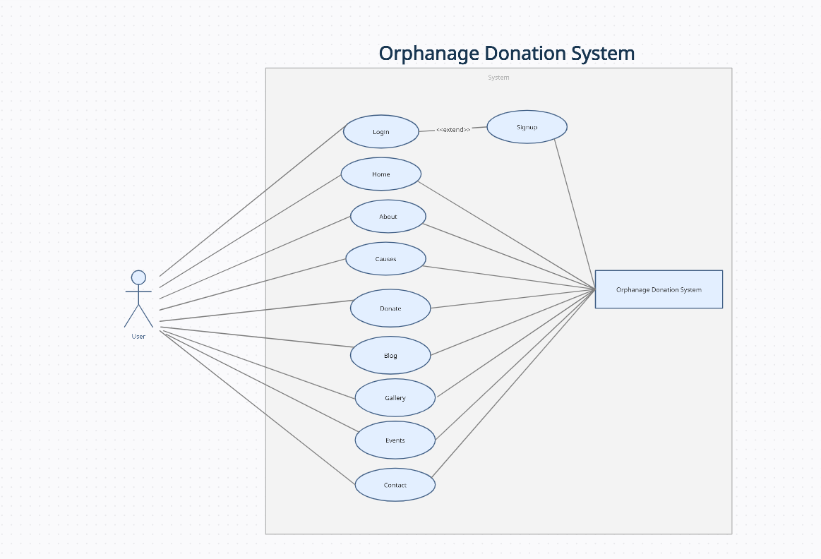

Diagram 5.1.1 Use case diagram

### 5.2 DFD

### 

Diagram 5.2.1 DFD

### 5.3 System Architecture

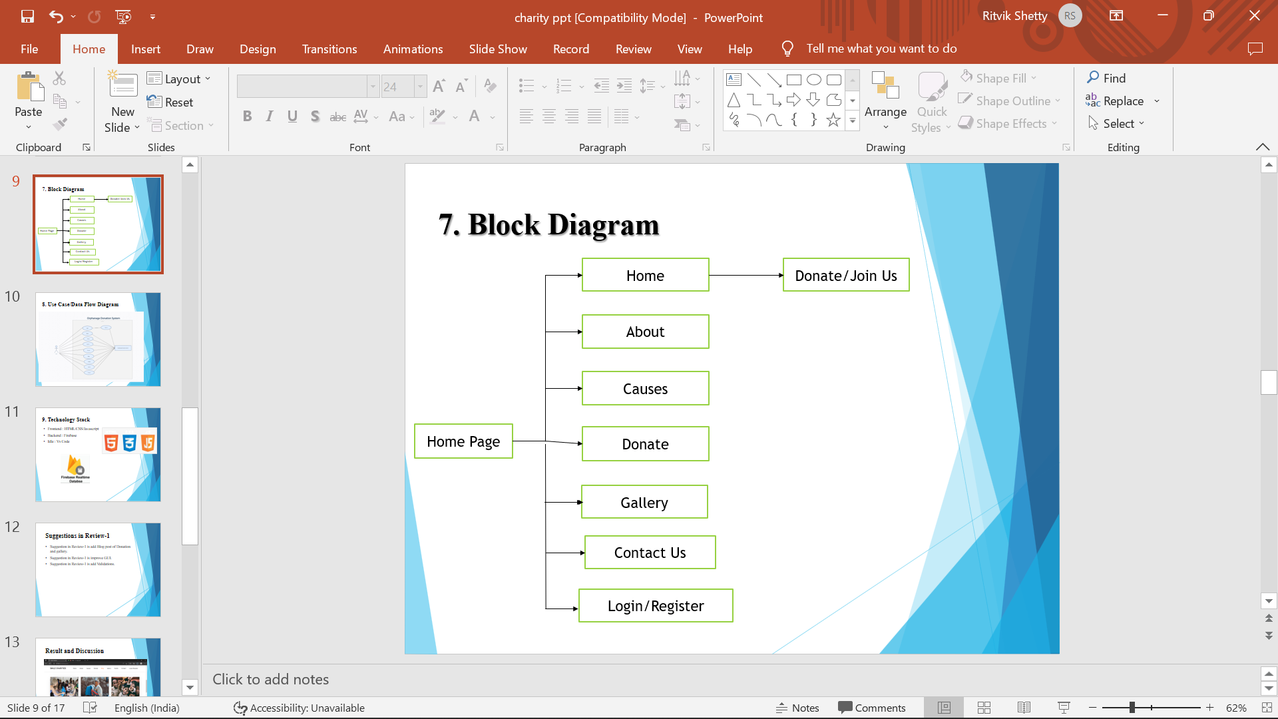

Figure 5.3.1 System Architecture

## Chapter 6 Technical Specification

**Development: VS Code**

VS Code also known as Visual Studio Code is a source code editor made by Microsoft for Windows, Linux, MacOS. It has various features such as Debugging, Syntax highlighting, extension, intelligent code completion.

**Frontend: Html, CSS, JavaScript**

As a web developer, the three main languages we use to build websites are HTML, CSS, and JavaScript. JavaScript is the programming language, we use HTML to structure the site, and we use CSS to design and layout the web page. These days, CSS has become more than just a design language, though. You can actually implement animations and smooth transitions with just CSS.

**OS : Windows**

Windows is a graphical operating system developed by Microsoft. It allows users to view and store files, run the software, play games, watch videos, and provides a way to connect to the internet. It was released for both home computing and professional works.

**Backend: Firebase**

Firebase is an app development platform that helps you build and grow apps and games users love. Backed by Google and trusted by millions of businesses around the world. Firebase is a Backend-as-a-Service (BaaS) app development platform that provides hosted backend services such as a real time database, cloud storage, authentication, crash reporting, machine learning, remote configuration, and hosting for your static files.

**Chapter 7**

## Project Scheduling

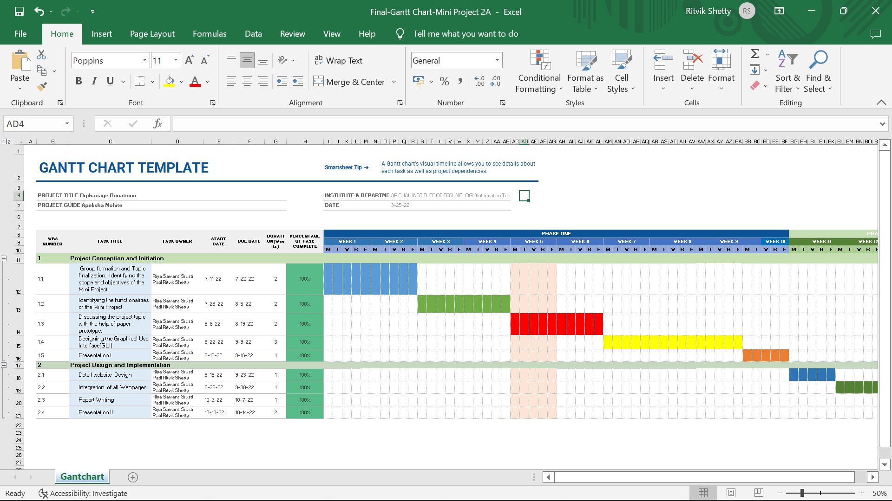

Figure 7.1 : Gantt Chart

Gantt charts help teams to plan work around deadlines and properly allocate resources. Projects planners also use Gantt charts to maintain a bird’s eye view of projects. They depict, among other things, the relationship between the start and end dates of tasks, milestones, and dependent tasks. Modern Gantt chart programs such as Jira Software with Roadmaps and Advanced Roadmaps synthesize information and illustrate how choices impact deadlines

## Chapter 8 Implementation

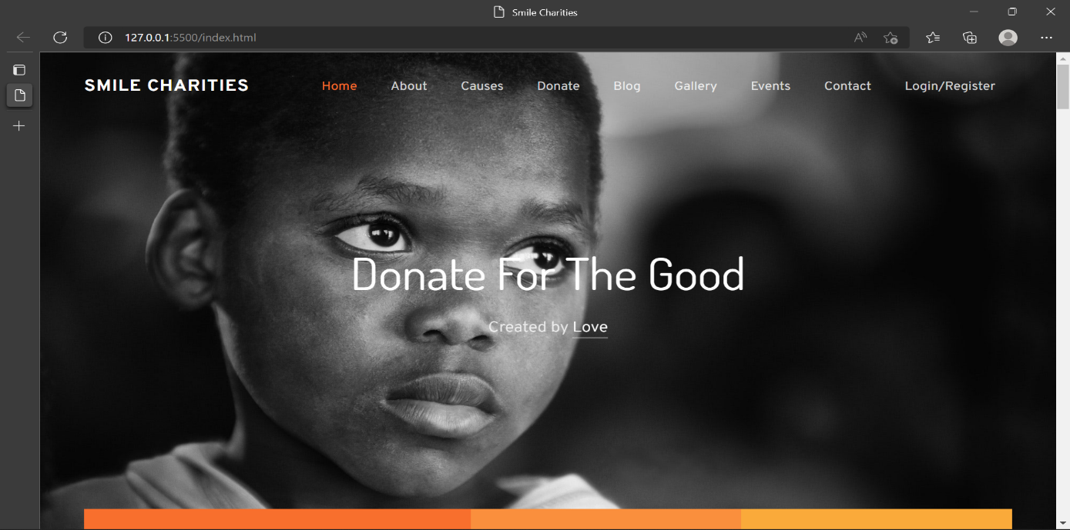

**Fig 8.1**: **Home Page**

Home Page: Home Page is the main page of the website through which the user can explore all the features or pages of website.

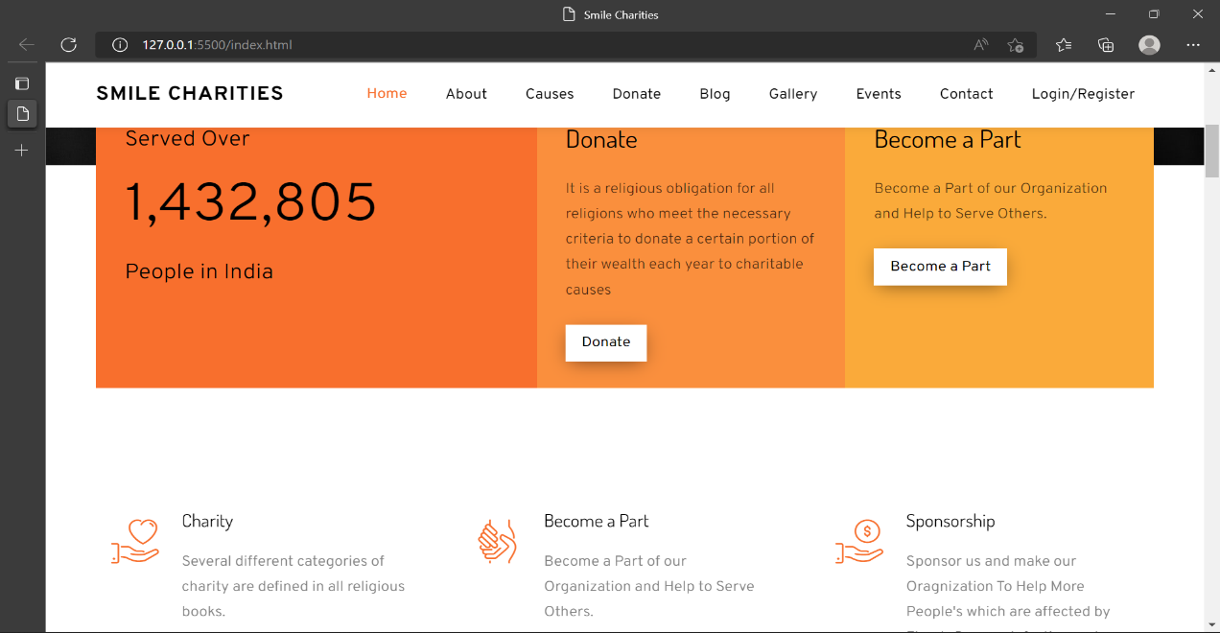

**Fig 8.2 : About us**

About us: About us is a part of home page in which we share our details and till date how many donations have been done and too provided with an emergency donation button.

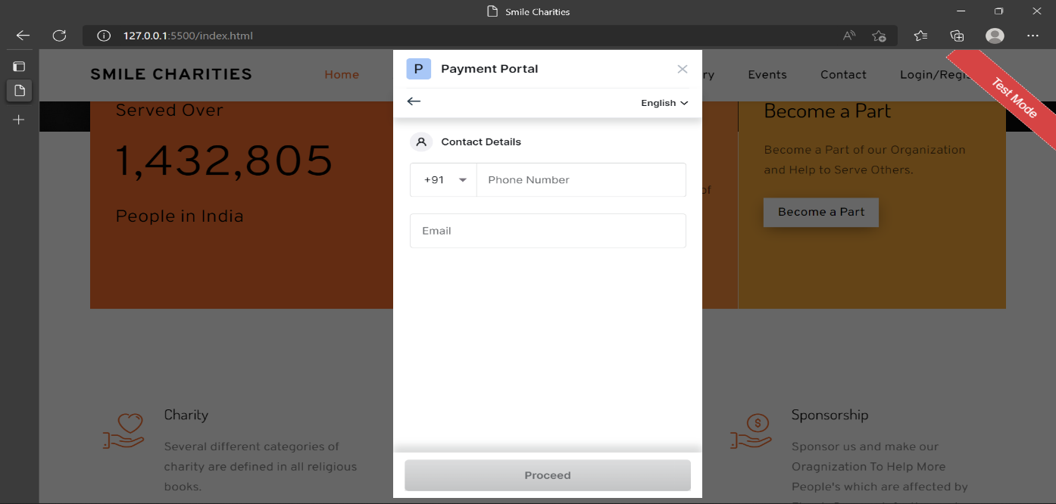

**Fig 8.3:Payment portal**

Payment Portal: Through Payment Portal Users can donate any amount, for that they have to enter mobile number and then select type of payment they have to proceed.

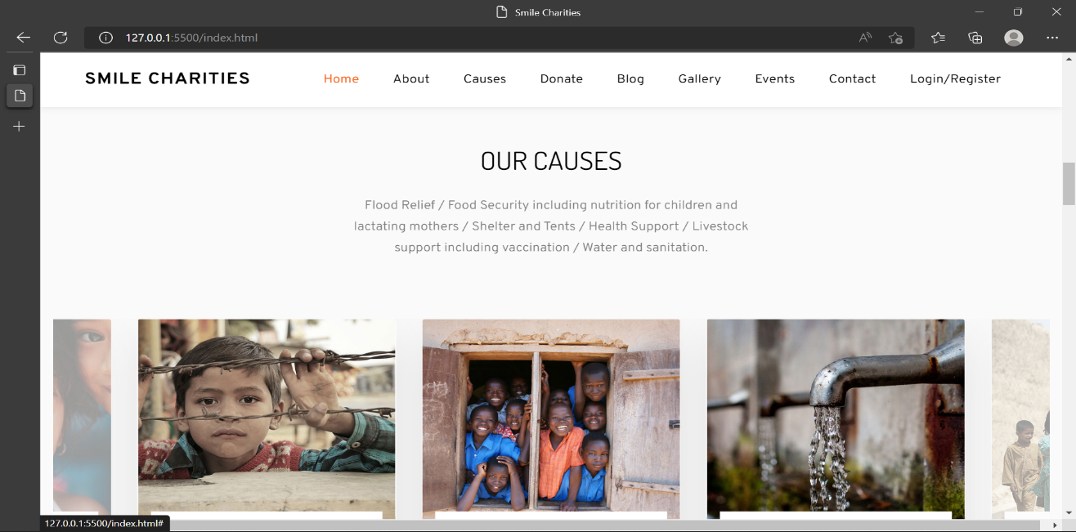

**Fig 8.4: Our causes**

Our causes: In this page, we provide donators with causes to donate for example recent earthquakes, floods or help children with education and many more.

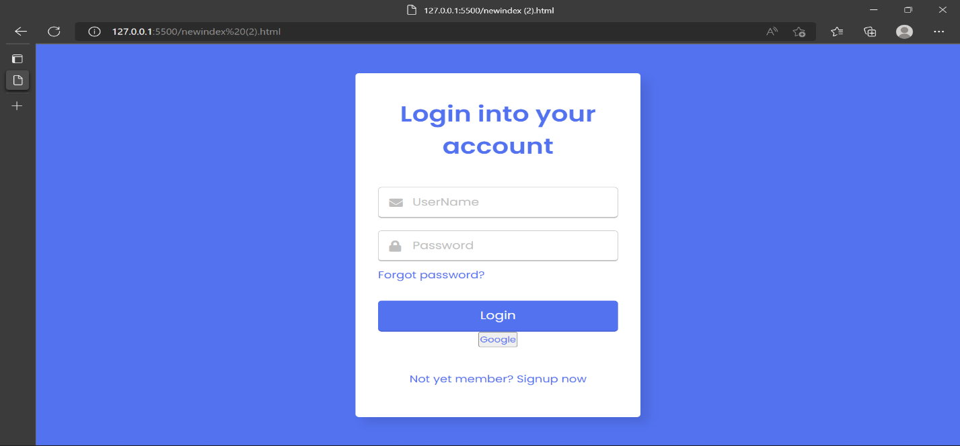

**Fig 8.5 :Login**

Login Page: Through this, Users can login if they have registered themselves in our website.

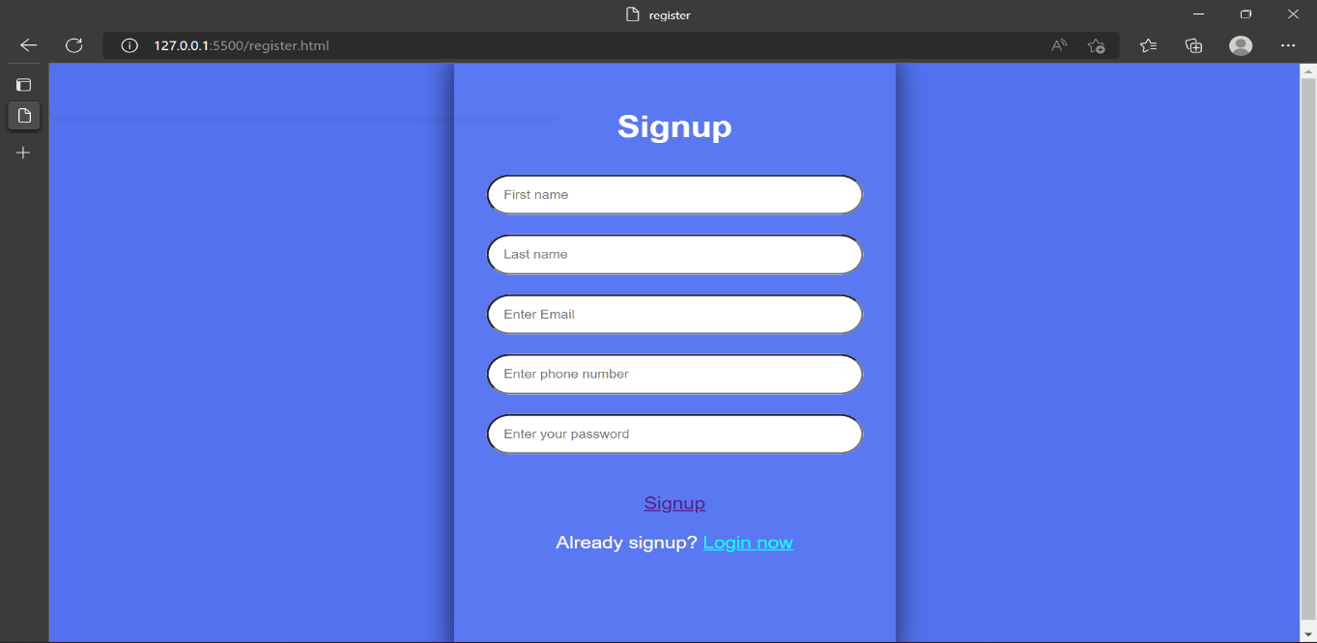

**Fig 8.6 :Register**

Register Page : Users not having an account on our website can register here by filling their details and then login with registered details.

**Chapter 9 Result and Discussion**

* Suggestion in Review-1 is add Blog post of Donation and gallery.
* Suggestion in Review-1 is improve GUI.
* Suggestion in Review-1 is add Validations.

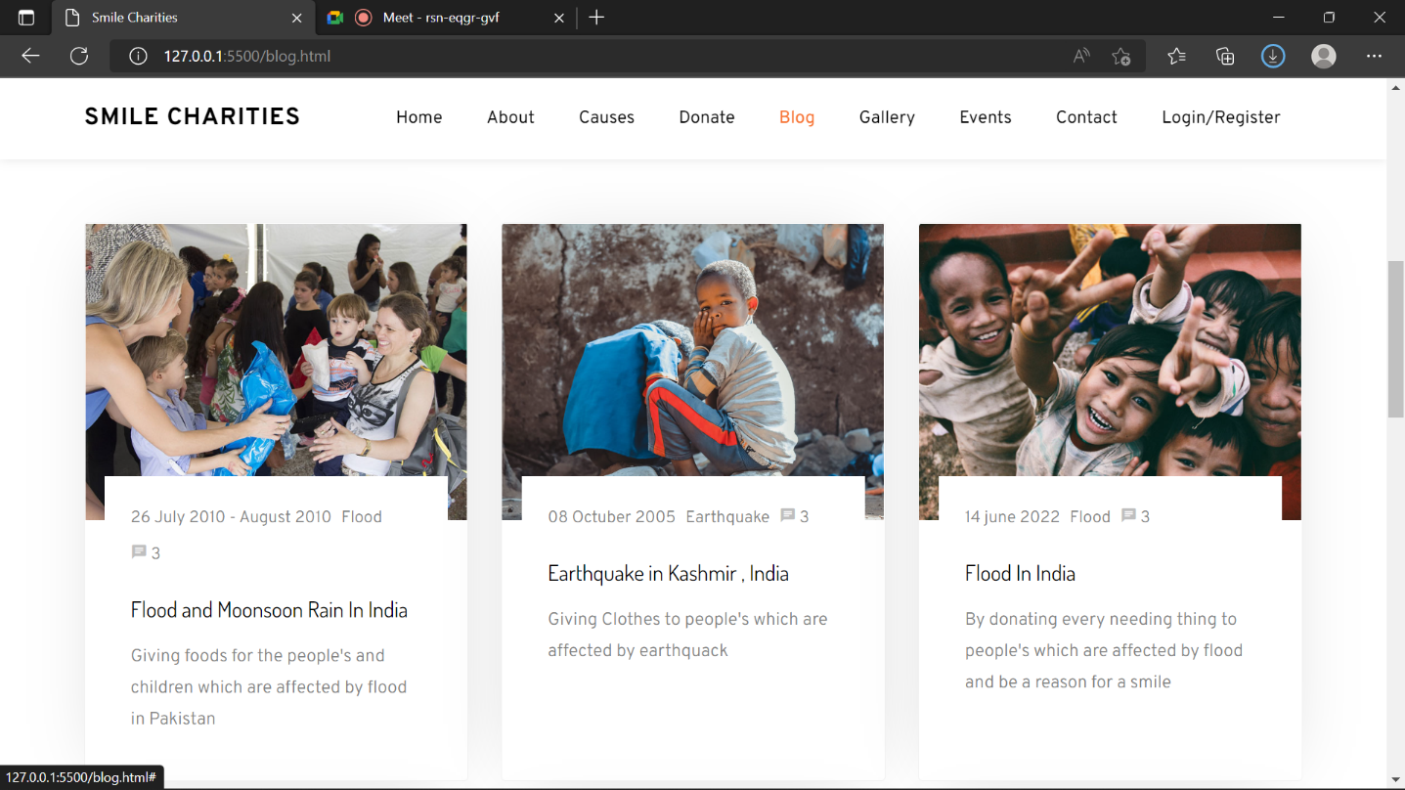

**Fig 9.1 Blogs**

Blogs : Here we have provided with blogs of how and where the urgency of donations is required and users can go though it and read it.

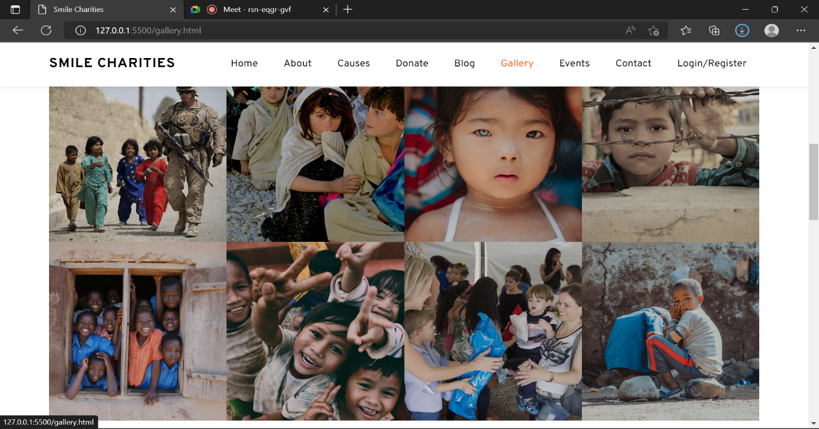

**Fig 9.2 Gallery**

Gallery : Through Gallery users can view the photos of various donations we have done through the donation amount.

## Chapter 10 Conclusion

Thus, the **Orphanage Donation Website** will provide a user friendly and easy interface to operate. User can login after registering their account in out website and then can start donating . A person can donate to any field he/she wants to donate without any much effort he/she just have to select the field where he wants to donate and just start entering the payment details. In future our website would be very helpful for orphanages to get donation so that they can help the needy ones. User can donate to the people in need without physically reaching out to them. As many organizations have found it difficult for collecting funds, so online mode is an easy way to reach out to for the people in need. Therefore, our aim is to provide proper service to the one donating

**Chapter 11**

## References

* https://www.networkforgood.com/resource/waukesha-county-food-pantry-case-study/
* https://www.researchgate.net/publication/340935234_A_literature_review_of_experimental_studies_in_fundraising
* https://forum.effectivealtruism.org/posts/gABGNBoSfvrkkqs9h/literature-review-why-do-people-give-money-to-charity
* https://www.ketto.org